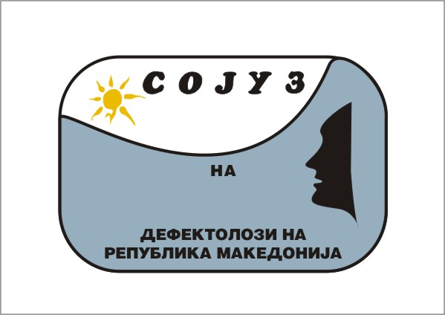 |  | ABSTRACT SUBMISSION  FORM  FIRST SIMPOSIUM FOR PERVASIVE DEVELOPMENTAL DISORDERS
“SCIENTIFIC ACHIEVMENTS AND PRACTICE IMPLEMENTATION”
15-17 May 2014 | Hotel Biser | Struga, Republic of Macedonia
Name |  |  |  |  | Surname
Profession
Institution
Country |  |  |  |  |  | City
Telephone
E-mail
Paper title
Co-authors |  |  | Name, surname, profession, institution they work in, address of the institution, e-mail address (it is mandatory to write all data)
Abstract |  |  | The text should contain to 300 words on Macedonian or English language. font Times New Roman 11

